|  |  |
| --- | --- |
| Subject: Data Analytics and Visualization Lab | Course ID: CSL-601 |
| Semester: VI | Course: AI & DS |
| Laboratory: 407 | Name of teacher: Prof. Gitanjali Korgaonkar |
| Name of Student: Ayush Gupta | Roll No: VU2S2324001 |

**EXPERIMENT NO. 6**

**Aim:**

To understand and implement Simple Linear Regression.

**Theory:**

**Introduction to Linear Regression:**

Linear Regression is a supervised machine learning algorithm used to model relationships between a dependent variable (Y) and one or more independent variables (X). It predicts the output based on a best-fit line that minimizes the error between actual and predicted values.

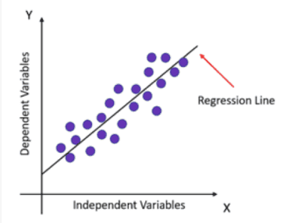

*Linear Regression Line*

**Mathematical Representation of Simple Linear Regression:**



where:

* y is Dependent Variable (Target)
* x is Independent Variable (Feature)
* β0​ is Intercept (value of y when x = 0)
* β1​ is Regression Coefficient (Slope)
* ε is Random Error

Since the best-fit line does not pass through all data points perfectly, an error term (ε) is included.

**Algorithm for Simple Linear Regression:**

1. **Load the dataset** containing independent (X) and dependent (Y) values.
2. **Calculate regression coefficients** (β0 and β1​):
   * Compute XTX and check if its determinant is zero.
   * If the determinant is nonzero, calculate regression weights ws.
3. **Use the regression equation** to **predict** Y values.
4. **Sort the data points** and **plot the regression line**.

**Flowchart for Simple Linear Regression:**

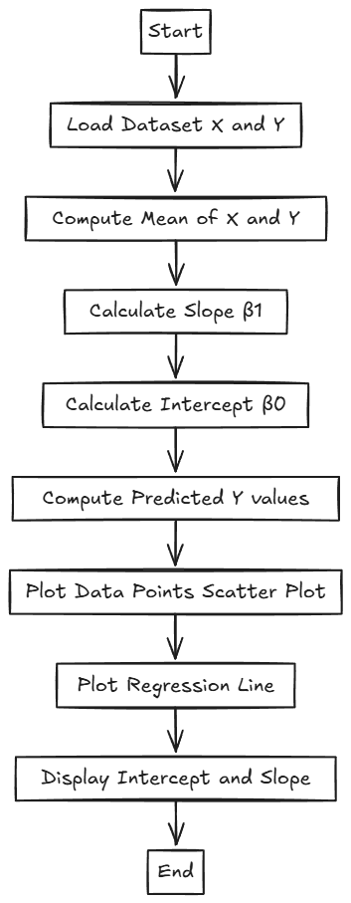

**Other Types of Linear Regression:**

1. **Simple Linear Regression**:
   * Involves only **one** independent variable.
   * Example: Predicting sales revenue based on advertising spend.
2. **Multiple Linear Regression**:
   * Involves **more than one** independent variable.
   * Example: Predicting house prices based on size, location, and number of rooms.
3. **Non-Linear Regression**:
   * When the relationship between variables **is not linear** (e.g., quadratic or exponential).

**Learning Objectives:**

* To **understand** the concept of **Simple Linear Regression**.
* To **implement** Simple Linear Regression using Python.
* To **visualize** the regression line and interpret results.

**Conclusion:**

Simple Linear Regression is a fundamental statistical technique used to predict numerical values based on past data. It plays a crucial role in business forecasting, trend analysis, and data-driven decision-making. By analysing the relationship between an independent and a dependent variable, regression helps in making informed predictions and identifying trends. With the availability of powerful libraries like scikit-learn in Python, implementing regression models becomes efficient and straightforward, allowing businesses and researchers to apply predictive analytics with ease.

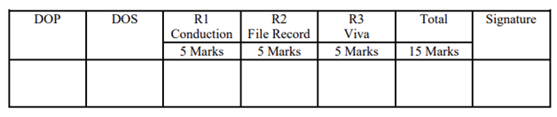

**Program and Output:**

* 1. **Simple Linear Regression in Python:**

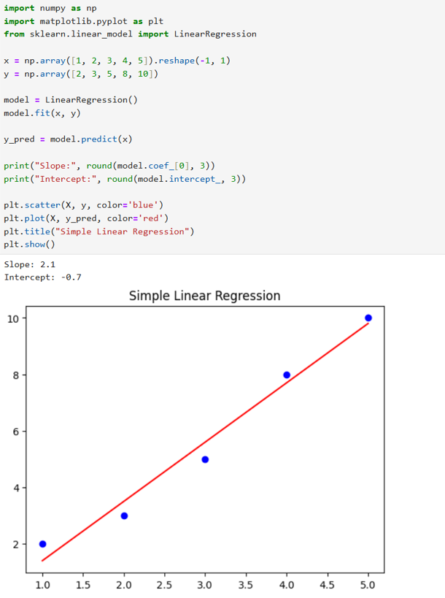

* 1. **Simple Linear Regression in R:**

